Agency Admin Meeting
March 27, 2020
10:30 – 12:00
Via Webinar

Attendees: Ana Contreras, Daniel Dickens, Alyssa Hoekman, Tim Weese, Marie Hickman, Cassidy Cockle, Lise Stuart, Katie Dockery, James Ewell, Mike Fleck, Adele Berlinski, Bonnie Haight, Zach Goodenough, Foster Martinez, Melinda Zugelder, Daina Davisson, Amy Cook, Dana Peterson, Heather Sielicki, Shannon Smyth, Pam Nyburg, Casi Totten, Carrie Copeland, Chris Pickering, Cara Ashworth, Danielle Bautista, Josh Muller, Mirtha Sturgo, Teresa Roark, Susanne Fendler, Arwen Maas-Despain, Sarai Johnson

- By Name List – Daina/Lise
  - Lise showed the Homeless By-Name Lists and other Tableau dashboards for April 2020
  - These dashboards will be on the Lane County Website soon
- SVDP – Housing Staff Changes July 1st – Bonnie Haight
  - Foster Martinez – Housing Program Director
  - Zach Goodenough – SSVF Program Manager
  - Jackie Low – SSVF Assistant Program Manager
  - Bonnie Haight – Leaving First of July for Medical School
- Fiscal exits
  - Agencies do not have to do the Fiscal year exits. These will be automatically done by WellSky
  - Melissa will send out an a list of providers that will be auto exited
  - Staff must create new project entries starting 07/01/2020
- Report for no EE but services
  - ART report available to check to see if there are Service Transactions will not open Entry Exits
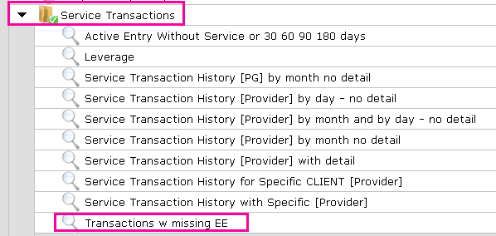
- TAC update – Sarai Johnson/Joint Shelter and Housing Strategist
  - TAC report went off of numbers originally from the point in time count. Now with the BY name list we know the real number
  - June 5th demobilization date for the Lane County respite shelters
  - 250 beds lost due to COVID 19 restrictions
  - Lane County and cites working to identify sites and safe places to sleep
  - TAC dovetailing into recovery efforts
  - Prioritizing housed to stay housed
  - Programs starting to review in July - Outreach teams, CE changes/phased assessments, rapid resolution how to resolve before they enter into our system
  - Navigation center – The former VA clinic on River Ave. has been purchased it will, at this time, be used for COVID response before being used as a navigation center, a date TBA.
  - Planning for 75 bed low barrier shelter
  - New PSH projects
    - 1100 Charnelton - 45 unit project. Construction starts Spring 2021, lease up Summer 2022
    - MLK - 51 units, construction is happening. Lease up Jan 2021, fully leased by May 2021
    - 13th & Tyler St- 13 homeless families with minor children. Construction starts Sept 2020, Lease up Summer 2021
- Satisfaction survey
  - Thank you to all who completed the survey
  - Will be sending out the results
  - Our team wants to hear from you
    - Questions
    - Comments
    - Feedback
    - Improvements
- Next Meeting
  - July
  - Doodle poll will be sent soon

